Foundation of GEN AI - Lab 01

Submitted by: ShivaDhanush S
USN: 1RVU23CSE428

Email text generation

Tools: Chat Gpt 5.2

Prompt:
# Role
Act as the Official Sports Coordinator for RV University. You are professional, energetic, and highly organized, with a focus on encouraging student participation and sportsmanship.
# Context
We are organizing an inter-college Football Tournament. - Venue: [RV University/College Ground] - Dates: [3/2/26 - 5/2/26] - Format: [e.g., Knockout ] - Registration Deadline: [25/1/26]
# Target Audience
The student body, including both seasoned athletes and casual sports enthusiasts. The tone should be motivating and clear.
# Task
Write a comprehensive invitation email to the students. The email must include: 1. An exciting subject line that grabs attention. 2. A brief opening highlighting the spirit of the game. 3. Logistics: Date, Time, Venue, and Equipment requirements. 4. Registration Details: How to sign up and the deadline. 5. Prizes/Recognition: Mention certificates, trophies, or bragging rights. 6. A call to action (CTA) encouraging teams to register immediately.
# Constraints - Minimum word count: 250 words. - Format: Use professional email etiquette (Salutation, Body, Sign-off). - Structure: Use bullet points for logistics to ensure readability.

Output:
Subject: ⚽ Kick Off the Action: Register Now for the Inter-College Football Tournament 2026!
Dear Students,
The roar of the crowd, the thrill of competition, and the unifying spirit of football are back on campus. RV University is proud to announce the Inter-College Football Tournament 2026, an event that celebrates teamwork, discipline, sportsmanship, and the sheer passion for the beautiful game. Whether you are a seasoned footballer or a student who thrives on competitive energy, this tournament promises high-intensity matches and unforgettable moments.
We invite enthusiastic teams from across the student community to participate and showcase their skill, strategy, and determination on the field.
Tournament Logistics
- Venue: RV University / College Ground
- Dates: 3 February 2026 – 5 February 2026
- Format: Knockout Tournament
- Reporting Time: Matches will commence daily from 8:00 AM; teams must report at least 30 minutes prior to their scheduled match
- Equipment Requirements:
  - Proper football boots (studs recommended)
  - Team jerseys with visible numbers
  - Shin guards (mandatory)
  - Personal water bottles
Registration Details
- Registration Deadline: 25 January 2026
- How to Register:
  - Team captains must register their team through the official Sports Office registration desk or via the registration link circulated on the university notice board and student portals.
  - Each team must submit a complete player list as per tournament guidelines.
Prizes and Recognition
- Championship and Runner-Up Trophies
- Certificates for all participating teams
- Recognition for Best Player, Best Goalkeeper, and Top Scorer
- Above all, campus-wide recognition and bragging rights for the winning team
This is your chance to compete, connect, and create memories that extend beyond the classroom. Form your team, train hard, and register without delay. Slots are limited, and late entries will not be entertained.
Let us come together to make this tournament a true celebration of football at RV University.
Warm regards,
Official Sports Coordinator
Department of Sports & Physical Education
RV University

Image generation

Tool: Nano banana
Prompt:
/imagine prompt: A high-intensity anime-style sports poster for "RV UNIVERSITY INTER-COLLEGE FOOTBALL TOURNAMENT 2026", inspired by the art style of "Blue Lock".

Key Visual Elements:
The central figure is a dynamic striker in a dark blue and black RV University kit, captured in mid-air performing a powerful volley kick. The player is surrounded by an exploding aura of electric cyan blue and fiery orange energy that forms jagged speed lines and shattered glass effects around them. Their eyes are glowing intensely. The soccer ball at point of impact is deforming from power, emitting blinding light.

The background is a stylized, imposing football stadium at night, looking almost futuristic and gladiatorial, with massive stadium lights cutting through a dark, atmospheric sky. The ground beneath the player is cracking from the force of the shot.

Color Palette:
High contrast. Dominant deep indigos, electric neon blues, and sharp cyan, contrasted aggressively with blazing oranges, radiant yellows, and deep blacks.

Typography & Text Layout:
The text must be bold, futuristic, and aggressive, integrated into the action.
1. At the top center, stylized text: "RV UNIVERSITY PRESENTS"
2. Below that, huge, blocky, fractured title text with blue and orange gradients: "INTER-COLLEGE FOOTBALL TOURNAMENT 2026"
3. A tagline across the middle in jagged font: "KICK OFF THE ACTION. UNLEASH YOUR GAME."
4. At the bottom, a structured data block with glowing borders containing: "DATES: 03 FEB – 05 FEB 2026" | "VENUE: RV COLLEGE GROUND" | "FORMAT: KNOCKOUT" | "REGISTER BY: 25 JAN 2026"

Composition:
Vertical (portrait) aspect ratio. The composition should feel explosive and center-focused. --ar 9:16 --stylize 250 --v 6.0

Output:
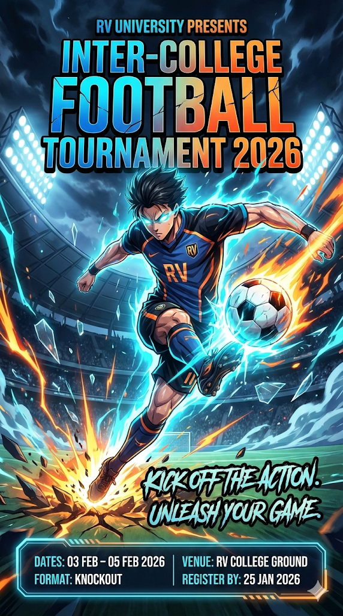

Video Generation

Tool : Hailuo AI
Prompt :
Create a 20-second anime-style promotional video for an Inter-College Football Tournament 2026, inspired by the Blue Lock anime art style and using the uploaded poster as a visual branding reference.
Style & Tone:
- Blue Lock–inspired anime realism
- Sharp facial features, intense eyes, dramatic expressions
- High-contrast lighting, strong shadows, visible sweat
- Competitive, psychological, high-stakes football atmosphere
Scene Flow:
0–3s: Extreme close-up of a player’s focused eyes, stadium blurred behind.
3–7s: Clean ball control and short passes between teammates, fast cuts.
7–12s: One-on-one dribbling duel, sharp direction change, speed lines only (no fantasy effects).
12–15s: Striker prepares and shoots on goal, slow-motion foot-to-ball contact.
15–18s: Bold title reveal: “INTER-COLLEGE FOOTBALL TOURNAMENT 2026”.
18–20s: Event details overlay:
- 03–05 FEB 2026
- RV College Ground
- Knockout Format
- Register by 25 Jan 2026
Final text: “Kick Off the Action. Unleash Your Game.”
Camera & Motion:
- Dynamic anime angles, close-ups, fast cuts
- Dramatic pauses before key actions
Color & Lighting:
- Cool blues with neutral tones
- Stadium floodlights with rim lighting
Audio (if supported):
- Crowd ambience, breathing, boot-ball impact
Duration: 20 seconds
Aspect Ratio: 16:9
Quality: Ultra-high quality anime sports promo, no watermarks.

Output: https://github.com/Shiva666666/Gen-AI-lab1

